 | 20.3.4 Editors - NLA Editor - Sidebar - View Tab
Table of content
Sidebar - View tab 1
Marker options panel 1
Lock Markers 1
Sidebar - View options panel 1
Show Markers 1
Show Local Markers 1
Show Seconds 2
Sync visible range 2
Show Control F-Curves 2
Real-time Updates 2

Sidebar - View tab
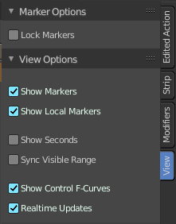
The view tab contains further options.

Marker options panel

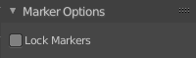
Lock Markers
Make the markers uneditable.
The Drivers editor does not have Markers. This panel is dysfunctional and obsolete here. And will vanish soon

Sidebar - View options panel
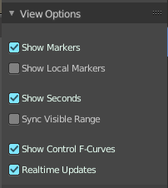

Show Markers
Display the markers.

Show Local Markers
Show action-local markers on the strips.

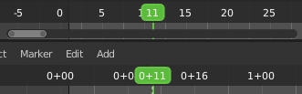
Show Seconds
Show the timing in the timeline area in seconds instead of frames.

Sync visible range
Synchronize the visible timeline range with other visible time based editors.

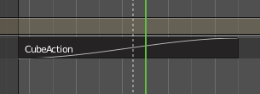
Show Control F-Curves
Shows existing f-curves in the action strip. Like for keyframed Animated influence.

Real-time Updates
When transforming strips in the NLA editor, the other animation editors updates too.

